GTB  
  
**QA**  
[DEV 20.14] OT-840 | XT | CZ | AS | Request a Contact Popin v1 – 14 April 2020

**Jira ticket:**  
<https://jira.uhub.biz/browse/GTBEMEAOPT-840>

**Site**  
<https://www.ford.cz/>

**Test location**  
All pages except on BnP

**Hypothesis**  
Analysis on the TDR Popin and UC5 has shown that TDR Popin converts at a higher rate than UC5 for TDR Completes. We know that we can expect the conversion rate to be 100% higher than onsite conversion. As such, we want to ensure we keep leveraging this popin and its audience even during the pandemic. However, we will be shifting our focus to "Contact Us" to maintain a touch-free approach.

**Test Description**

**NOTE:** This activity does run in Incognito.

View the BnP Start and Finish link. Click on the "Konfigurátor” link in the main heading. On the left there’s an option to pick "Osobní vozy” or “Užitkové vozy” ~ Select vehicles from both sides.   
The following vehicles are excluded from the test: Fiesta ST, Focus ST, Mustang, Ford Ranger Raptor  
  
Next view the “Only on profile script true” link. After 10 seconds a popup should appear.

If the vehicle you viewed is from the “Osobní vozy” option and not a “Ranger” the popup that appears should look something like the below.

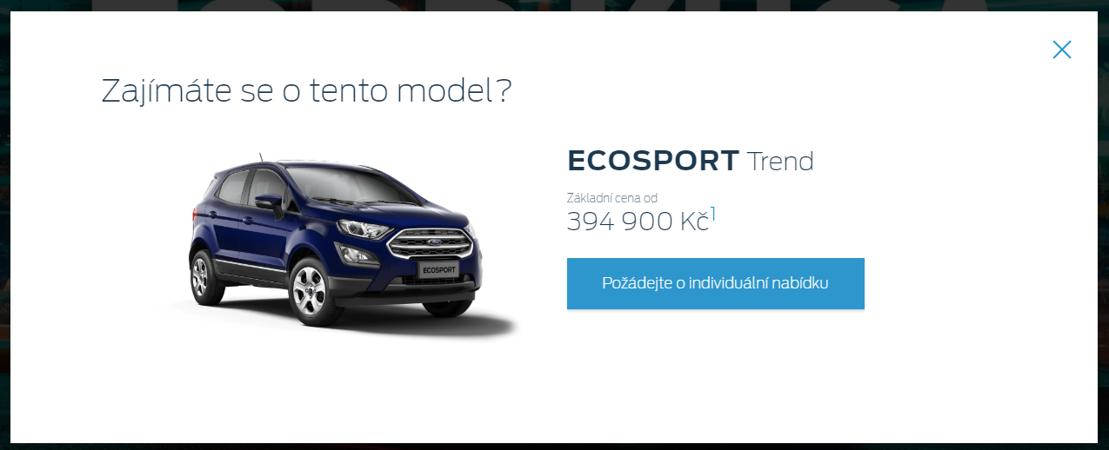

When you click on the “1” link a smaller popup should appear that looks like the below:

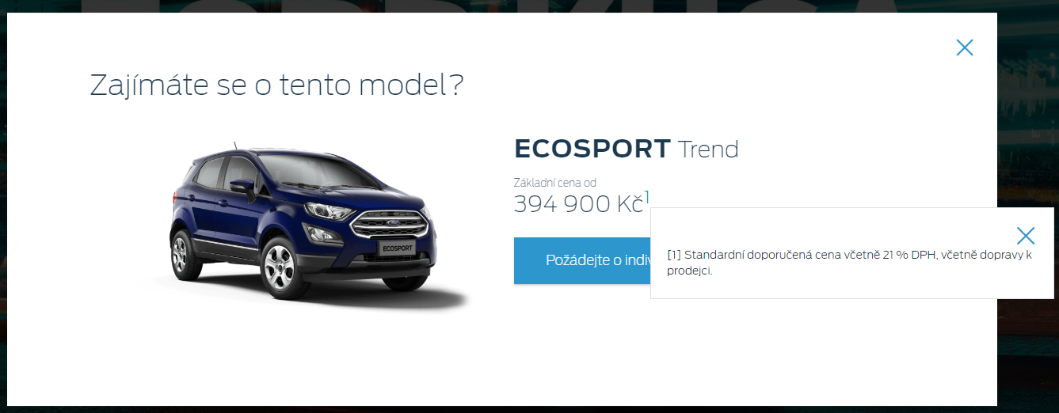

If the vehicle you viewed is a Ranger or from the “Užitkové vozy" option, the popup should look like the below:

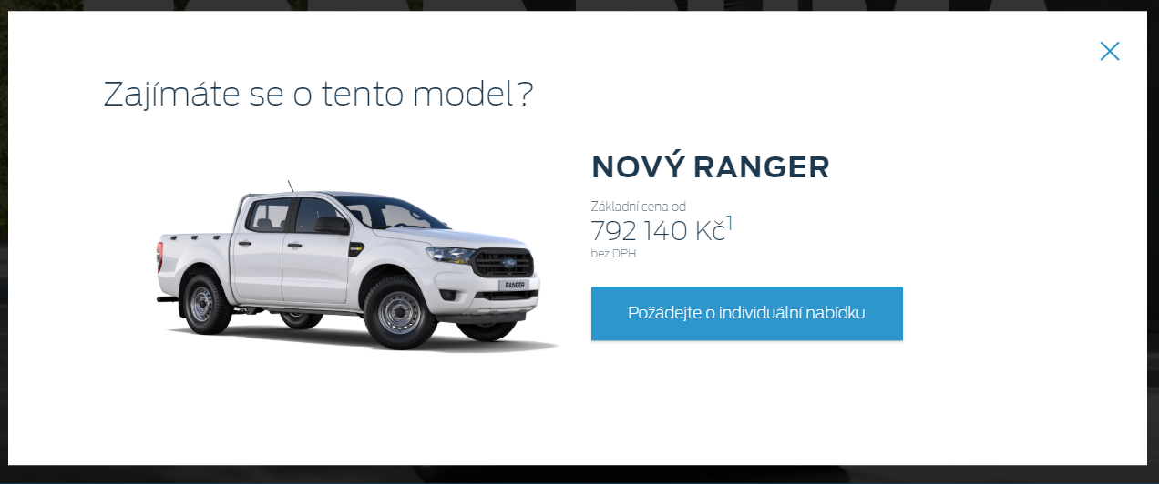

When you click on the “1” link a smaller popup should appear that looks like the below:

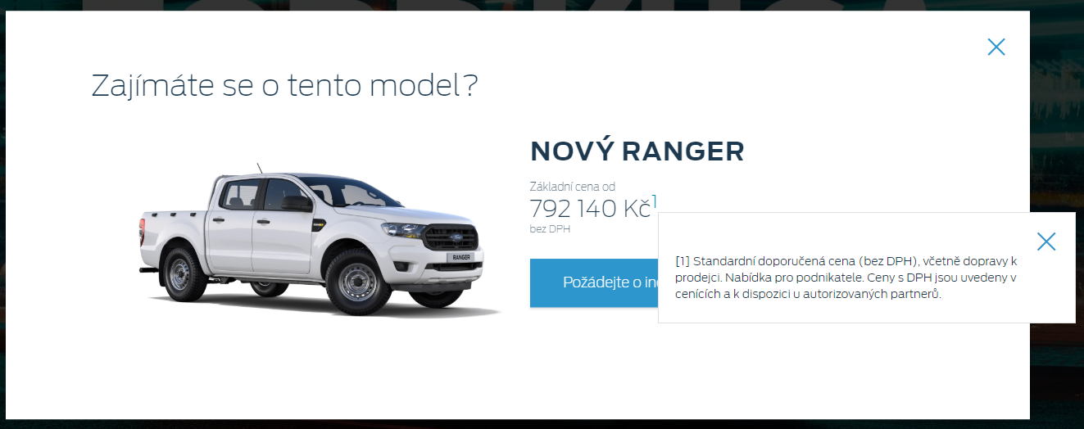

Based on whether the vehicle has an offer or not, the text above the price would be different either being:  
  
“Základní cena od” - If it’s not an offer price.  
OR  
“Zvýhodněná cena od” - If it has an offer price.

It’ll only show 1 price. Either the offer price or the retail price.

When you click on the button on the popup, you should be directed to the following page:

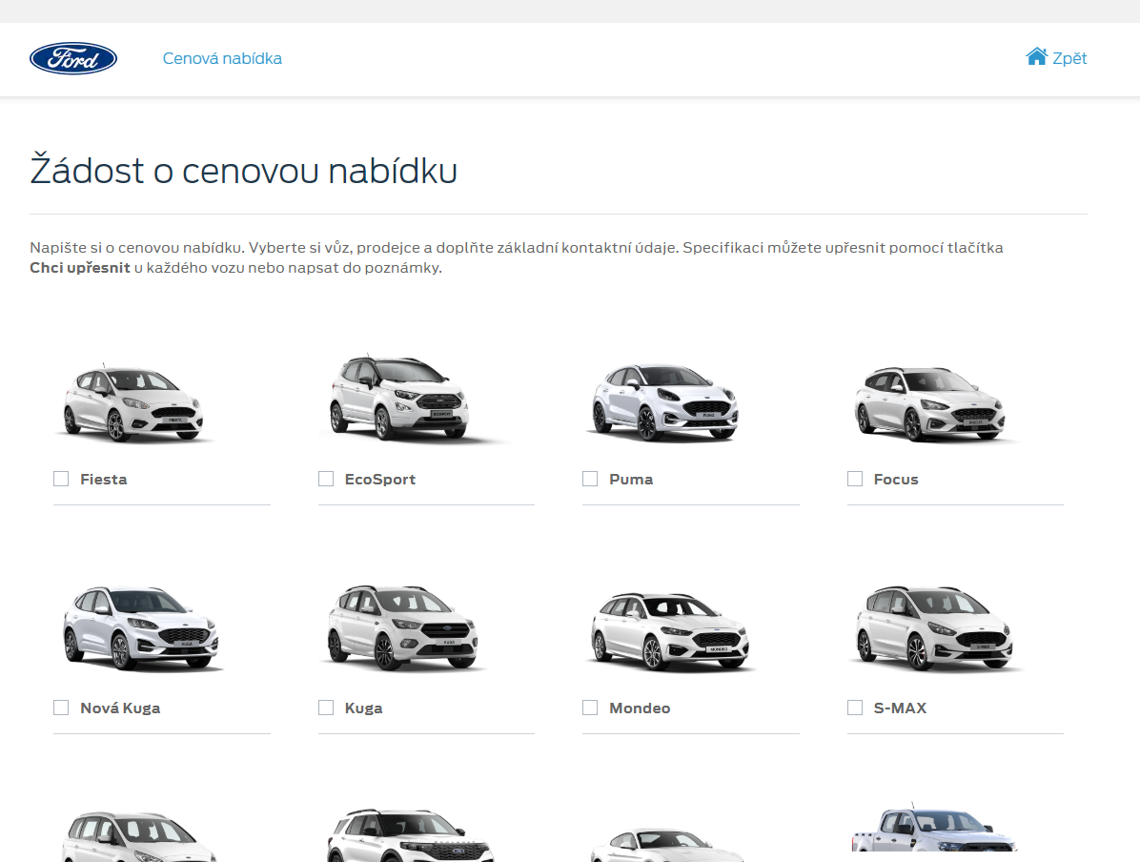

**Browser:**   
All  
  
**Device:**   
All  
  
**Audience rules:**   
All traffic

**QA Links:**

BnP Start and Finish:

<https://www.ford.cz/?at_preview_token=zMRq6H8te1f9xDq92z46TA%3D%3D&at_preview_index=1_1&at_preview_listed_activities_only=true>

Only on profile script true: <https://www.ford.cz/?at_preview_token=zMRq6H8te1f9xDq92z46TA%3D%3D&at_preview_index=1_2&at_preview_listed_activities_only=true>